

**ISRA UNIVERSITY HYDERABAD**

**DEPARTMENT OF COMPUTER SCIENCE**

**FINAL YEAR PROJECT REPORT**

**VIRTULEARN**

**By**

|  |  |
| --- | --- |
| **Sandhia Maheshwari** | **2101-BSCS006** |
| **Amarta Devi** | **2101-BSSE018** |
| **Iraj Irshad** | **2101-BSSE020** |
| **Muskan Jatt** | **2101-BSSE003** |

**Supervised by**

**Dr. Sehrish Abrejo**

**Final year project report submitted in the partial fulfilment of the degree of Bachelors of Science in Computer Science**

**December 2024**



**FACULTY OF ENGINEERING, SCIENCE & TECHNOLOGY**

**DEPARTMENT OF COMPUTER SCIENCE**

**Certificate**

**This is to Certify that Sandhia Maheshwari, Amarta Devi, Iraj Ali and Muskan Jatt has worked under my supervision for the BS(CS)/BS(SE)/BS(TC)/BS(ES) project titled Virtulearn, as per partial requirement for the award of the degree of BS(CS)/BS(SE)/BS(TC)/BS(ES) and the work is original and satisfactory.**

|  |  |
| --- | --- |
| **Dr. Sehrish Abrejo**  **Supervisor**  **Department of Computer Science** | **Dr. Amber Baig**  **Chairperson**  **Department of Computer Science** |

**ACKNOWLEDGEMENT**

We are really thankful for the chance to reveal the results of our project, first and foremost one for them Allah! The Most Merciful and Most Beneficent, thanks to His invaluable teaching and help, we continually experienced his leading every crossroad. His protection was the reason that we could stand over all the barriers and finally reach the victory.

Our profound gratitude goes to our great supervisor, Dr. Sehrish Abrejo, for her indispensable help, constant encouragement, and the provision of her valuable feedback on this project throughout the period. Her expertise and care have played key roles in casting this work into its final design.

At the outset, I express my heartful appreciation to each teacher, guide, and faculty who shared their knowledge and experience so liberally that added value to our thinking and caused us to grow exponentially as never before.

We also want to say that we feel very grateful to our families for supporting us. The steadiness of their backing and also their distance did not stop them from being the source of our will power and high energy without which we never would have lasted through these years.

**ABSTRACT**

VirtuLearn is the most advanced AI learning management system, targeted at transforming traditional education. Traditional lectures essentially lead to passive learning; students are mere recipients of information. Lack of activity on the part of the learners hinders the effectiveness of their learning process and sustain interest in what they have learned.

The typical classroom environment presents a variety of challenges for students. This includes difficulty understanding complex concepts within a limited time frame. Dealing with the different learning speeds that may be left behind and the lack of personal advice on how to prioritize topics for further study.

VirtuLearn solves these problems by using advanced technology to provide an interactive and personalized learning experience. The platform has an automatic note-taking feature, creating dynamic quiz generation and comprehensive performance analysis. It provides students with an interesting and effective way to learn outside of the classroom. By using data-driven techniques and providing personalized feedback, VirtuLearn helps students stay focused on important topics. Improve remembering It also allows you to adapt to your own personal learning pace.

These abilities help teachers and students to improve teaching methods and learning outcomes, with the ability to provide customized learning experiences and increase overall student engagement. VirtuLearn is designed to save teachers valuable time and transform the future of education.

**TABLE OF CONTENTS**

Acknowledgement i

Abstract ii

Table of Contents iii

List of Figures iv

List of Tables v

CHAPTER 1 INTRODUCTION 1

1.1 Project Background 1

1.2 Problem Statement 1

1.3 Proposed Solution 2

1.4 Objectives 2

1.5 Scope of the project 3

1.6 Surveys 4

CHAPTER 2 5

LITERATURE REVIEW 5

2.1 Introduction 5

2.2 Overview of Traditional Educational Technologies That Do Not Have AI 6

2.3 Effectiveness of the Traditional Educational Tools 6

2.4 Effectiveness of AI-Based Tools in Teaching 7

2.5 AI in the Classroom: Revolutionizing Teaching and Learning 8

2.6 Promotion of Equal Access to Education 8

2.7 Challenges and limitations 8

2.8 Conclusion 9

**LIST OF FIGURES**

**LIST OF TABLES**

# CHAPTER 1

# INTRODUCTION

**1.1 Project Background**

Education is key to individual and national development processes; however, most conventional methodologies have resulted in failure in addressing the diversified needs of students. In Pakistan, due to the unavailability of personalized learning tools, the majority of students cannot keep pace with the classroom teaching, which causes gaps in understanding and reduces interest. VirtuLearn is specifically designed to address these challenges through the provision of an AI-enabled platform, extending a better and more interactive learning experience.

The project seeks to revolutionize learning by making it easily accessible and more effectively imparted for both students and instructors alike. VirtuLearn personalizes learning, overcomes the inefficiencies of passive learning, and generally improves educational outcomes in Pakistan.

**1.2 Problem Statement**

The primary concern addressed by the project is lack of personalized learning platforms for the diverse needs students have in a traditional educational system. Many students fall behind in class due to an inability to keep pace with learning and therefore miss critical concepts due to unmet needs for personalized support and feedback. Besides, further limitation by the insufficiency of interactive and real-time response methods develops the problem and makes students disinterested and uncaring about learning. VirtuLearn tries to remove all these obstacles by including an AI-driven platform where students can conveniently learn at their own pace, receive immediate feedback, and tap into personalized resources that ultimately enhance quality and reach in education.

**1.3 Proposed Solution**

The development of this solution involves building Virtulearn, a new artificial intelligence-powered learning platform that transforms the way learning is delivered. Unlike other systems, the VirtuLearn version will automatically generate personalized notes, quizzes, and feedback tailored to the individual learning needs of every student. This gives students the ability to learn at their own pace, spending more time in those areas of studies that they are weak in, hence increasing learning depth. VirtuLearn will break all time and location barriers, as learning can be accessed from any location, hence improving the level at which students engage with the course material. VirtuLearn is further intended to support teachers by simplifying course management and giving insight into student performance that makes modification in teaching strategies quite easy. The solution aims to improve the level of engagement and academic success of students by introducing a new personalized way of approaching education.

**1.4 Objectives**

The key objectives of VirtuLearn are the use of AI in the reformation of traditional education by providing students with personalized learning experiences, while making the teaching process easier for educators. At a time when AI had already become part of daily life, there wasn't anything quite like VirtuLearn, as it used AI powered features like auto-generation of notes, quizzes, and real-time feedback. Therefore, it is designed to be intuitive and user-friendly, hence easy for the student to go through and learn at their pace.

AI-powered tools will have teachers manage courses efficiently and draw useful insights on the progress of each student, fitting them into better teaching tactics. VirtuLearn shall be highly promoted among educational institutions, creating a strong platform that will begin catering to modern-day needs for both students and teachers. Virtulearn seeks to make quality education reach wider audiences by making learning more engaging and convenient through mobile applications for easy access.

**1.5 Scope of the project**

The scope of VirtuLearn will be immediately expanded to incorporate students of various disciplines in universities, but it will launch with the provision of AI-powered tools for learning topics most commonly taught in higher education institutions. Some of these include but are not limited to the following:

* **Computing science and IT:** are incorporating Python, Java, C++, Web Development, Data Structures, and Algorithms.
* **Commerce and Management:** Business Economics, Marketing, Finance and Entrepreneurship.

VirtuLearn will focus on students studying various degrees and aim to provide AI-driven personal learning solutions, tailored to the needs of the students based on the specific course requirements. Gradually, the platform will be broadened and more specialized topics will be reached with new and innovative means and materials that allow the drawing upon of an extremely vast area of disciplines on behalf of helping universities best assist their students.

**1.6 Surveys**

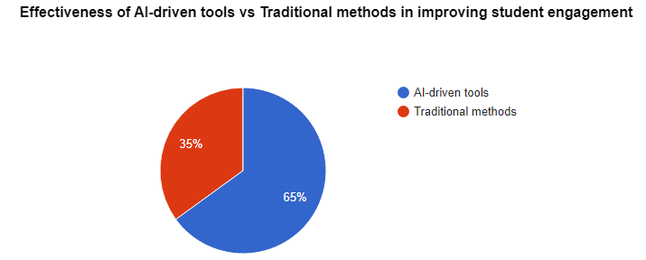

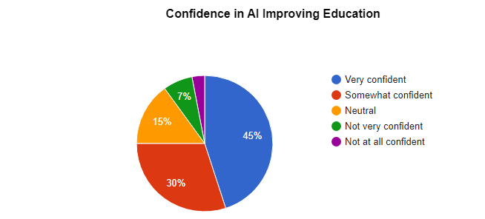

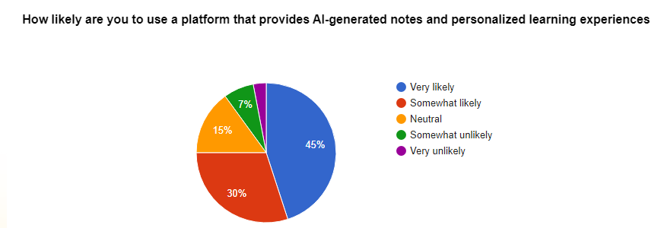

//more surveys will be added

# CHAPTER 2

# LITERATURE REVIEW

**2.1 Introduction**

The impact of technology in the classroom has transformed methods of traditional teaching and learning remarkably. VirtuLearn is AI-based, presenting an entirely new change in the delivery system of education addressing a wide range of challenges that confront students and teachers in traditional systems. This literature review establishes how AI is increasingly taking a role in education, discussing the capability of personalization about AI and development in technology, and how these innovations are bringing education to a wider audience through new advancements. The key focus of this review is trying to generate an effective understanding of how AI is transforming education and particularly its impact in Pakistan.

The review will be the positive and negative sides of artificial intelligence in education, with a special focus on how platforms like VirtuLearn enhance the engagement of students with activities, the optimization of learning through personalization, and enable teachers to work more intensely. This section will analyze current research and studies on what contributes to the higher quality of education and makes learning more impactful through the use of AI-enabled tools for various groups of students.

Under these technological innovations, the development of AI in education gains support: real-time feedback, automated content generation, and even adaptive learning systems. Most importantly, these technologies are going to further benefit the efficiency of AI-driven platforms, such as VirtuLearn, in addressing individual needs and filling gaps to conventional education. The review will therefore look at how artificial intelligence has opened gates in education, being inclusive of many different backgrounds and locations based on the virtue of high-quality personal learning experiences.

This review will also discuss the issues related to education with the use of AI, such as data privacy and access to technology, to study how to improve AI for education at every level without bias in its operations. Through this, the review would work to demonstrate how learning platforms such as VirtuLearn can mold future education by personalizing and making it efficient, thereby making it more accessible for students in Pakistan.

**2.2 Overview of Traditional Educational Technologies That Do Not Have AI**

Traditional educational technologies were effective, but highly resource intensive regarding time and effort from teachers. Enhancement of LMS, digital whiteboards, and presentation was visible in enhancing delivery, yet all these tools required extensive manual input from educators. In Moodle or Blackboard systems, they had to do everything themselves from developing course material, creating assignments, to creating quizzes this often resulted in a lot of wasted time.

Grading assignments and keeping track as well as providing feedback on all the traditional systems called for a lot of effort. In the traditional systems, grading became an enormous task because a teacher had to look at each student's work, give grades, and even write comments in great detail. The process can become slow and exhausting, especially when dealing with a large number of students. The tools lacked automation; therefore, every move associated with course management from uploading study material to tracking student progress-all depended on the teacher's time and energy.

Moreover, video conferencing technologies such as Zoom and Skype could have provided remote learning for students, but these had to be managed in real-time by teachers, unlike AI-driven systems, whose experiences change dynamically while being executed. These systems do not provide adaptive learning experiences and do not give real-time, fine-tuned feedback; teachers are responsible for noting where each student may need particular attention.

Overall, traditional educational technologies improved some aspects of teaching but were always time-consuming and required teacher’s constant involvement. Due to lack of automation and personalization, most of the workload, such as grading and lesson planning, as still done manually and repeated, making good use of this potential not fully realized.

**2.3 Effectiveness of the Traditional Educational Tools**

The traditional educational tools include learning management systems, digital whiteboards, as well as other online materials. They have helped in enhancing the organization and delivery of educational content. In this regard, these tools helped teachers in the distribution of study materials, relating with students, and in handling their assignments easily. However, they are largely less effective in some instances due to factors such as a lack of personalization and automation.

Though these traditional technologies have increased the availability of learning resources and have made remote learning more accessible, they are still time-consuming and require human effort on the part of instructors to manage duties such as marking, giving reviews, and monitoring student performance. Without real-time adaptive feedback, students' queries or needs are sometimes slowed down in their response, thereby limiting engagement and, ultimately, learning.

In this regard, while the basic tools have streamlined a bit every kind of education into an ever-smooth process, their influence on personalization and efficiency makes it difficult to address effectively students' diverse needs.

**2.4 Effectiveness of AI-Based Tools in Teaching**

The effectiveness of AI-based tools in teaching can be an extremely powerful emerging area for transforming traditional teaching and learning practices. Already, several studies have explored the effects of AI on the learning outcome of students, student engagement, and student satisfaction. Available evidence confirms that students who utilize AI-driven platforms, such as VirtuLearn, tend to perform better in comparison with students using conventional education methods. AI-based tools improve learning outcomes by providing a personalized learning experience. It is adapted towards the special needs, pacing, or learning styles of a specific individual.

It is possible through AI-powered platforms that provide students with instant feedback along with one-on-one support toward their betterment. For example, note generation and quiz preparation under VirtuLearn help the students concentrate on the important areas of learning and thereby master complex ideas relating to them. In this way, every student can learn as he learns and at his pace. He may fill in the gaps in what he or she already knows, thus gaining confidence over a period of time.

AI tools in platforms like VirtuLearn make education more accessible by removing time and location barriers. As AI-driven platforms run 24/7, students can have full access to teaching resources and guidance at any time, thus free from the constraints within a traditional classroom environment. Tools can also personalize learning content according to the student's development for a much more engaging and effective experience.

The AI-based tools worked very well, but there are still challenges. For instance, one of the concerns has to do with the quality of content created through AI and adequate preparation by teachers for the effective implementation of AI tools in the learning environment. Access is another challenge, as many students may not have the necessary devices or internet connection to fully benefit from AI-based education. Despite these difficulties, new applications such as VirtuLearn open up new chances for education through modern technologies that bring opportunities for creating more personalized and efficient learning environments that help the student achieve their full potential.

**2.5 AI in the Classroom: Revolutionizing Teaching and Learning:**

VirtuLearn brings an entirely new era of teaching and learning into the classroom with AI. Its content remains personalized for the students in adapting to their needs while supplying them with real-time feedback and automating items such as grading and quiz generation, among others. This will enable the teachers to spend more time on interactive and innovative teaching methods. The students will appreciate the readily available, flexible, and demand-based access to learning resources. VirtuLearn helps to improve the engagement and learning outcomes of students while ensuring education can now be more efficient, accessible, and tuned to the student's individual pace.

**2.6 Promotion of Equal Access to Education:**

VirtuLearn is the platform that every student, whoever he or she might be, from whatever background he or she may come from, and whatever his or her unique learning requirements are, can enjoy equal grounds for education. It is in this context of my FYP that VirtuLearn tries to remove some of the barriers which inherently limit quality education in this or any other field where sharp-minded students from different localities could not contribute as much to education based on mobility limitations or fewer facilities available in their region.

**2.7 Challenges and limitations:**

Although VirtuLearn transforms education through AI, there are numerous limitations that constitute significant challenges. For example, the success of the tool is diminished by lack of devices and a steady internet in many underserved places. To implement the tool in the classroom of an educator, the educator also needs additional training. AI-based systems do not offer the emotional support human educators have historically given to students. Another issue is data privacy, as AI bases its personalization on student information; there is a possibility that some of the data or feedback AI renders may sometimes be wrong. Last, AI's capability to perform challenging abstract tasks is still in its infancy stages and therefore may limit use in certain areas of learning.

**2.8 Conclusion**

VirtuLearn is going to transform education. Regarding the limitations of traditional learning, VirtuLearn offers potential for changing this because it connects AI-driven tools with the more meaningful personalization of the student learning experience. Such a system brings about a very high engagement level with students and efficiency among the teachers. The automated features such as note-taking and quiz generation support students precisely, leaving room for more relevant teacher-student interactions.

Therefore, VirtuLearn essentially bridges the geographical and financial barrier to equal access to quality education opportunities for all learners. Along the way toward developing AI, VirtuLearn will thrive in learning results and meeting diverse educational needs in shaping a future that is even more tailored to inclusive education.